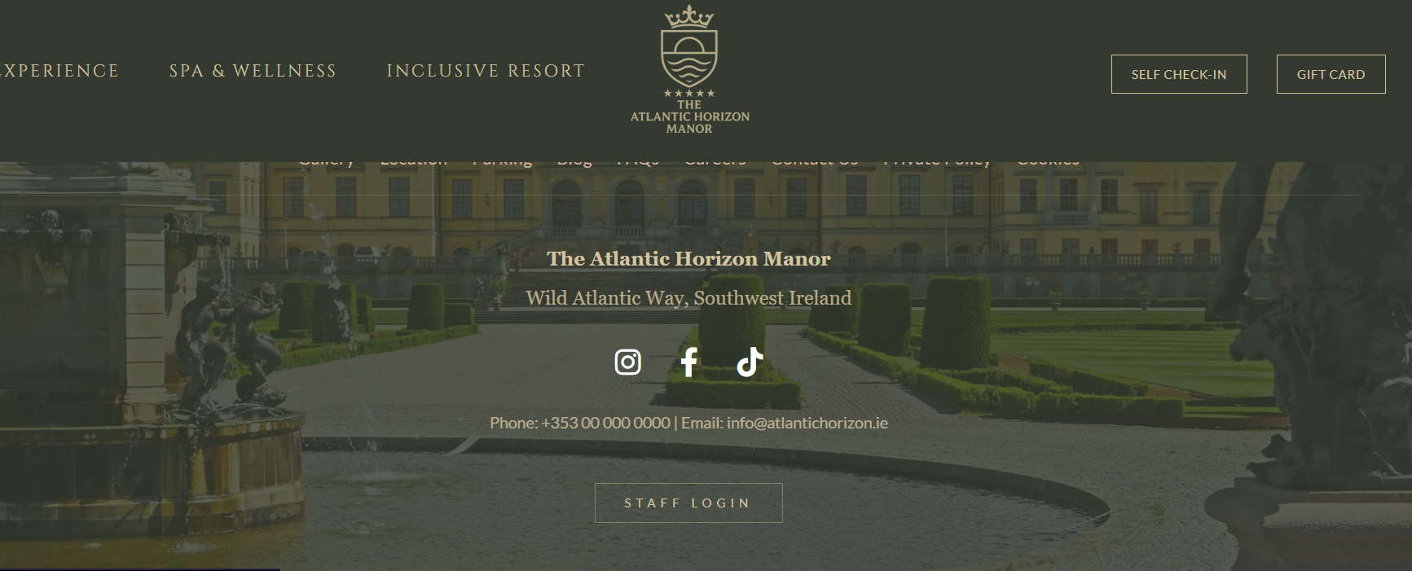
The staff profile is located here. I would be hidden and when the cursor hover on it, it will appear.
Case sensitive
This is the user which uphold the most authority
Username: boss
Password:123
Payment Strip Sandbox
Card number: 4242 4242 4242 4242
Everything else could be random
Customer Self Check in
Booking Code: ATL-647056
Email: griffith@gmail.com
Redeem Gift Card

